**National Institute of Technology Surathkal Karnataka**

**Engineer – 2018**



MIDI Glove

By: Krish Lohia

Sriram A

B Alagu Parvathy

**Abstract/Aim of Project:**

It is a glove which play diﬀerent tunes when it is moved

**Parts Needed/Used:**

Arduino UNO, MPU 6050, Bluetooth Module, Loop MIDI, Hairless MIDI, FL Studios, Power bank, Glove, Laptop

**How it works:**

MPU 6050 is a gyroscope which measures the angle and the measured quantity is passed to the Arduino using I2c protocol. The code is written in such a way that a particular tune is assigned to a range of angle, free space is divided into bins and when the gyroscope reads that angle, the corresponding tune MIDI no. is passed to the hairless MIDI using the Bluetooth module. Hairless MIDI passes it to FL Studio through the virtual port created by Loop MIDI and the tune is played.

Loop MIDI is a software which can create new ports through which communication takes place. Once the port is created the second software which is Hairless MIDI is now opened with the Bluetooth of the laptop being switched on. For wireless communication as we are using Bluetooth port 4 or 5 have to be selected in Serial port and the virtual port which is created using Hairless MIDI in Serial out option. Open FL studios go to options then select MIDI settings and link the MIDI out port to FL studios. Select the instrument and it is ready to play

**Steps:**

1. Most important part is the code, which interfaces MPU to the Arduino
2. Assemble the hardware’s (connecting MPU and Bluetooth to Arduino)
3. Link the software’s to the Arduino, and it is ready to play

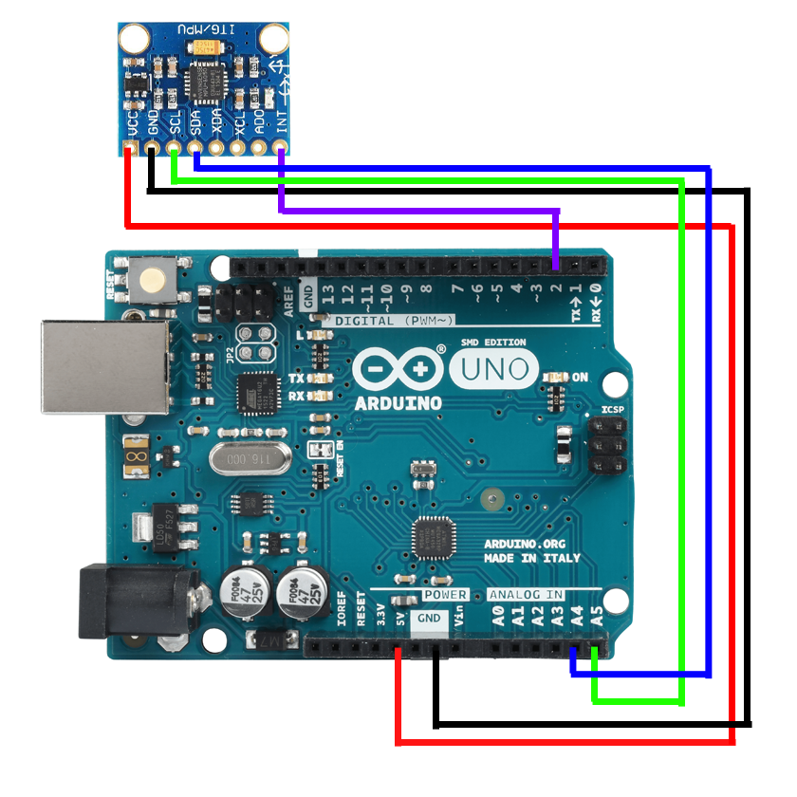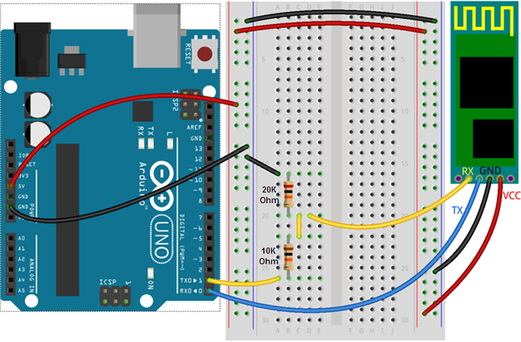

*If there is some problem with Bluetooth try connecting state pin of bluetooth to ground

**Problems Faced**

Automatic disconnection and random functioning of Bluetooth after using it for some time. Bluetooth gets heated up, so let it cool down.

**Important links**

Code: <https://drive.google.com/file/d/1GkOK1g_D1P9xHM0kwd1zqNjiIVRryXLb/view?usp=sharing>

Email id’s: [krishlohia7@gmail.com](mailto:krishlohia7@gmail.com) ; [sriram03a@gmail.com](mailto:sriram03a@gmail.com) ; [bapalagu1999@gmail.com](mailto:bapalagu1999@gmail.com)